**Basics**

**Linguistic levels of language understanding**

**Lexicon**: Words segmentation (tokenisation; decompounding) / normalization (capitalisation; acronyms; spelling variants) / morphology (Lemmatisation: reduce to base form; Stemming: reduce to root (worried-worr); Byte-pair encoding and wordpieces; Part-of-speech tagging)

**Syntax**: Sentence structure (Parsing)

**Semantics**: Meaning of words and sentences (Word sense disambiguation; Compositional meaning; Semantic role labelling)

**Discourse**: Meaning of a text (Relationship between sentences; Coreference resolution)

**Pragmatics**: Intentions, commands

**DL formulas**:

**Sigmoid**: $f\left(x\right)=σ\left(x\right)=\frac{1}{1+e^{-x}}$

**Tanh**: $f\left(x\right)=\tanh\left(x\right)=\frac{e^{x}-e^{-x}}{e^{x}+e^{-x}}$

**CE**: $L=-\frac{1}{N}\sum_{i=1}^{N}{\sum_{c=1}^{C}{y_{c}^{\left(i\right)}\log\left({\hat{y_{c}}}^{\left(i\right)}\right)}}$

**Word Representations**

**One-hot encoding**: (Size = seq_len*vocab_size)

**Problems**: 1. Orthogonal definitions 2. High dimensionality (and sparse) 3. Fixed vocabulary (OOV)

**WordNet**: mapping words to broader concepts (+) Maps some similar words together, Reduces vector size (-) Relies on the completeness of a manually curated database, Misses out on rare and new meanings, Vectors are still orthogonal, Disambiguating word meanings is difficult

**Word2Vec**: a family of NN based algo to obtain word embeddings.

**Architectures**: CBOW and Skip-gram

**Training strat**: Hierarchical Softmax and Negative Sampling

**Continuous Bag-of-Words**: Predict the target word based on the surrounding context words

**Skip-gram**: Predict the context words based on the target word

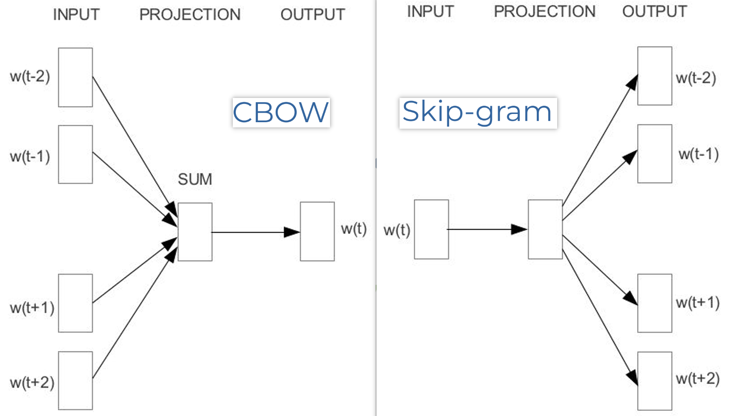

**Calculation of Skip-gram**:

1. Select i-th row of word embedding matrix.

2. Calc similarity (sort-of) of j-th column of context matrix and softmax it to get probs.

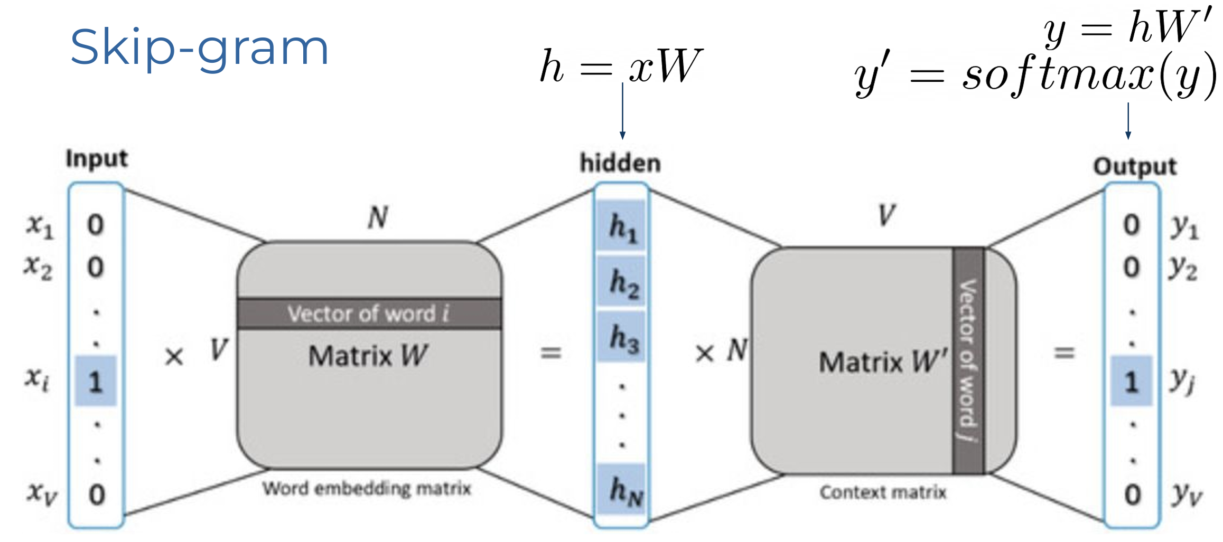

**How to train Skip-gram**:

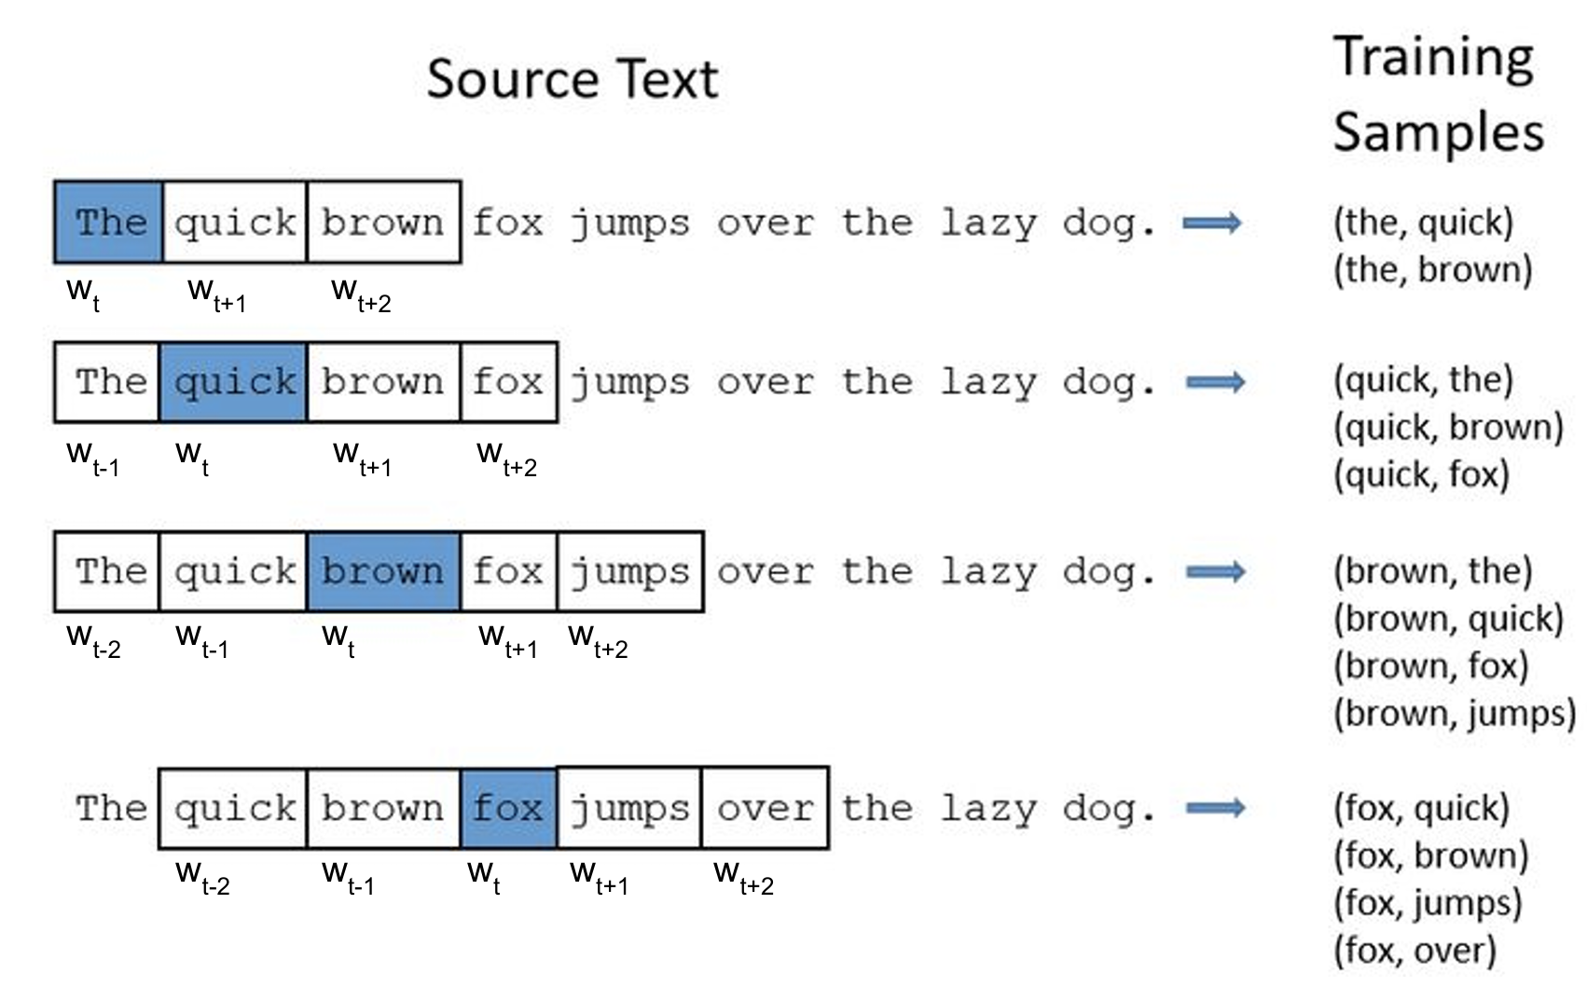

**Objective function**: $\frac{1}{T}\sum_{t=1}^{T}{\sum_{-c≤j≤c,j≠0}{\log{p}\left(w_{t+j} | w_{t};θ\right)}}$

**Prob**:

$$p\left(w_{t+j} | w_{t}\right)=\frac{\exp\left(u_{w_{t+j}}^{⊤}h_{w_{t}}\right)}{\sum_{w^{'}=1}^{W}{exp(u_{w^{'}}^{⊤}h_{w_{t}})}}$$

**Negative sampling** (Approx. softmax):

$$\log{p}\left(D=1 | w_{t},w_{t+1}\right)+kE_{\tilde{c}∼P_{noise}}\left[\log{p}\left(D=0 | w_{t},\tilde{c}\right)\right]$$

**Example**:

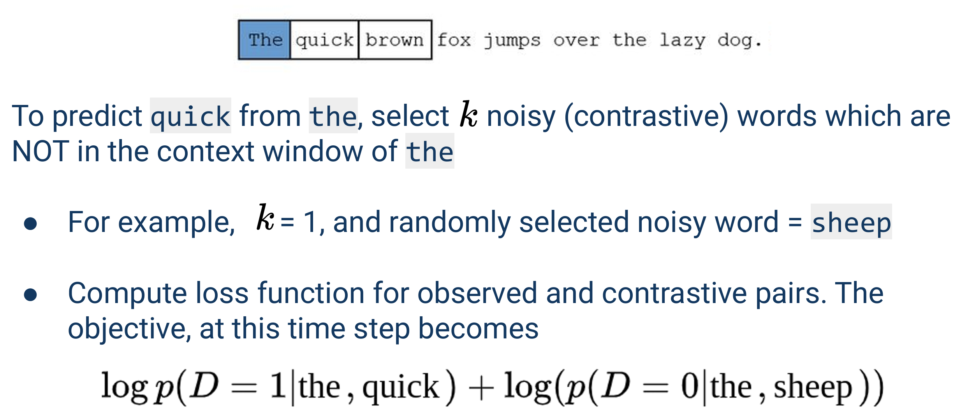

**Prob**:

$$p\left(D=1 | w_{t},w_{t+1}\right)=\frac{1}{1+\exp\left(-u_{w_{t+1}}^{⊤}h_{w_{t}}\right)}$$

**How to select K**: 5-20 negative words works well for smaller datasets. 2-5 for large datasets

**Calc example**: Weight mat $D×V$, update $1+k$ words and $\left(1+k\right)×D$ parameters need to be updated, which is $\left(1+k\right)/V ×100\%$ of weights in the output (context) layer.

**Noise Distribution**:

Frequency based > random sampling

Random: $p\left(w_{i}\right)=\frac{1}{\left|V\right|}$

Freq: $p\left(w_{i}\right)=\frac{f{\left(w_{i}\right)}^{3/4}}{\sum_{w^{'}}{f{\left(w^{'}\right)}^{3/4}}}$

**Analogy recovery**: ‘apple’ is to ‘apples’ as ‘car’ is to ‘cars’

**Discussion of Word Embeddings**:

(+) 1. Require only plain text 2. Very easy to use 3. Pretrained vectors are available 4. Help models start from an informed position (-) 1. Required large amounts of train data 2. Low quality for rare words 3. OOV 4. Antonym反义词 tend to have similar distributions 5. Morphological similarity is not considered 6. Does not differentiate between different meanings of a word

**Byte Pair Encoding**:

**Issue of white space tokenization**: Large vocabs; Cannot deal with OOV

**How to train BPE**:

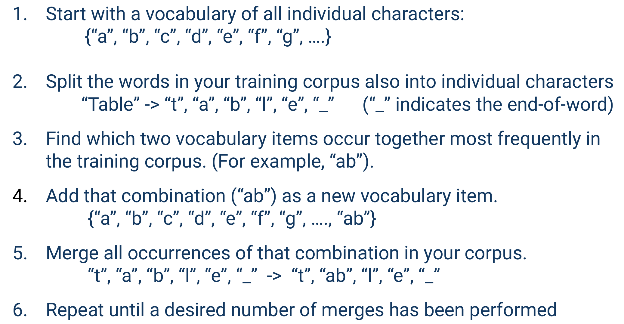

**Example**:

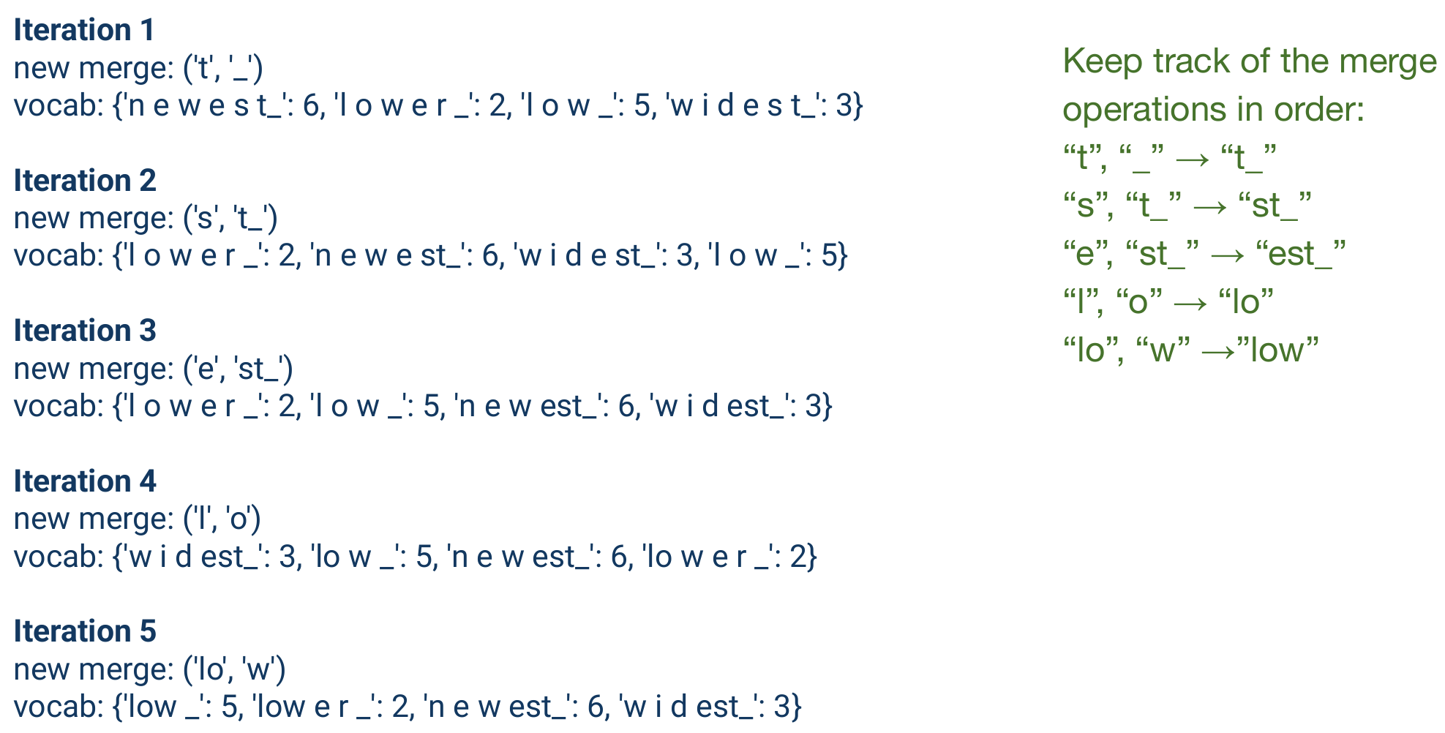

**End-of-word symbol**: 1. Distinguish suffixes 2. Tell us where to insert spaces

**Inference Algorithm**:

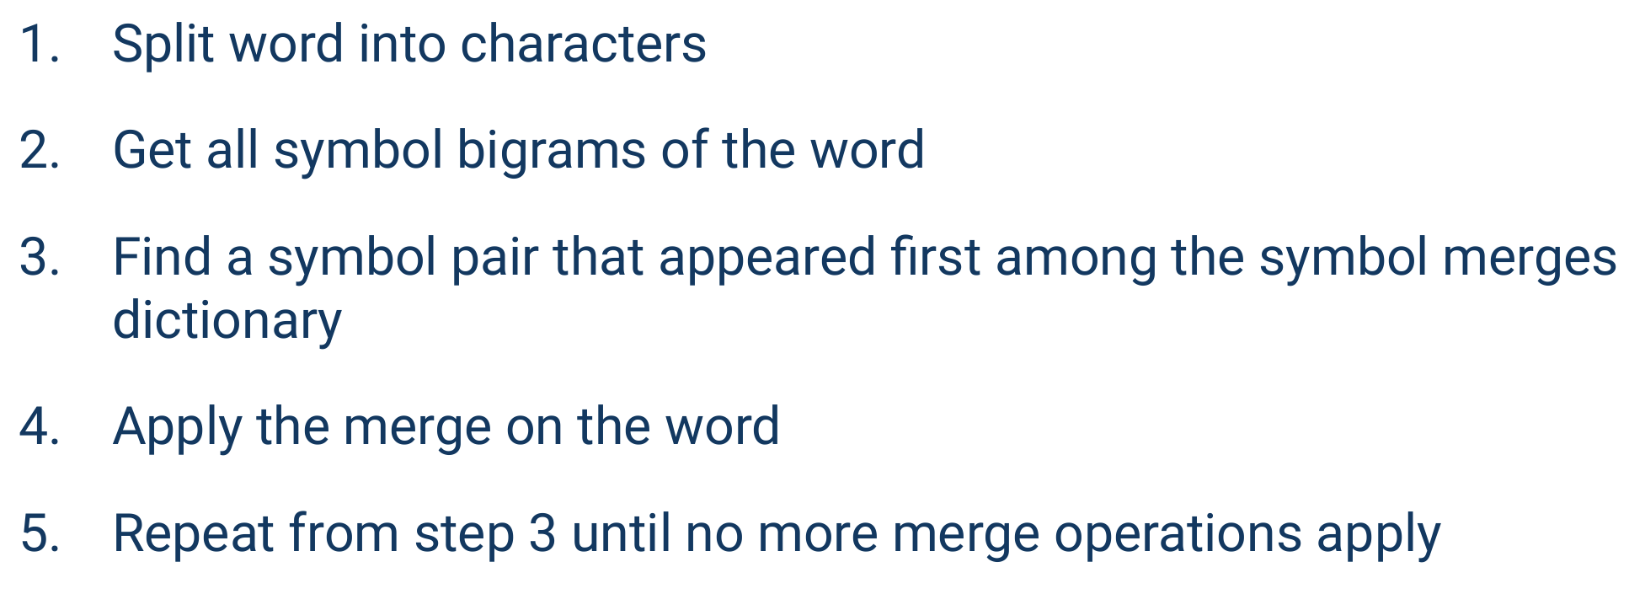

**Example**:

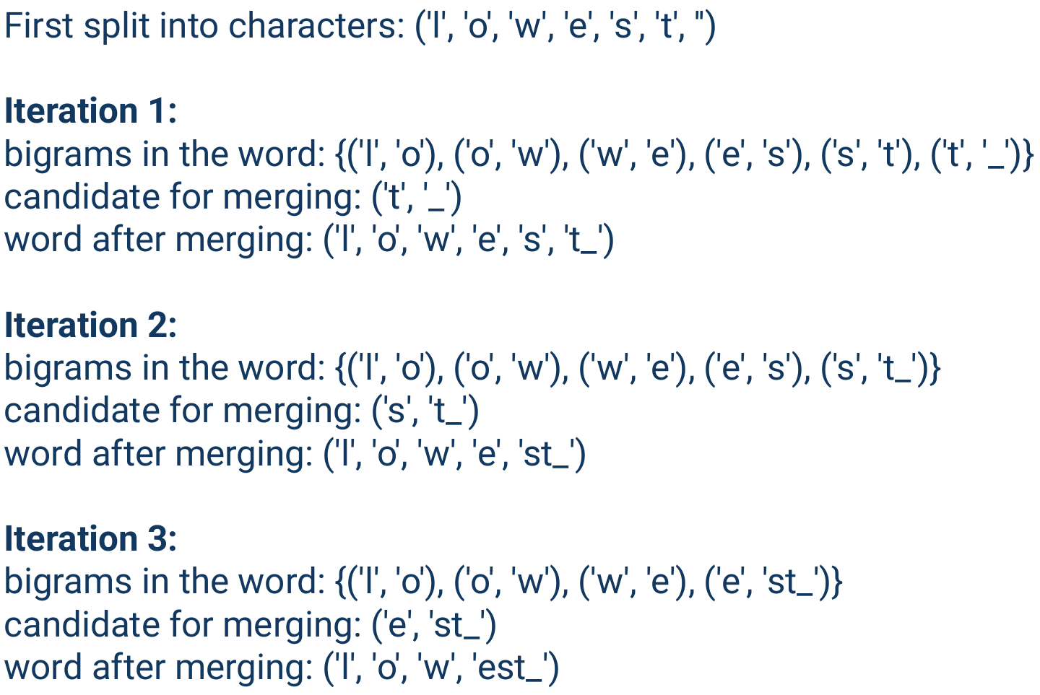

**TF-IDF**:

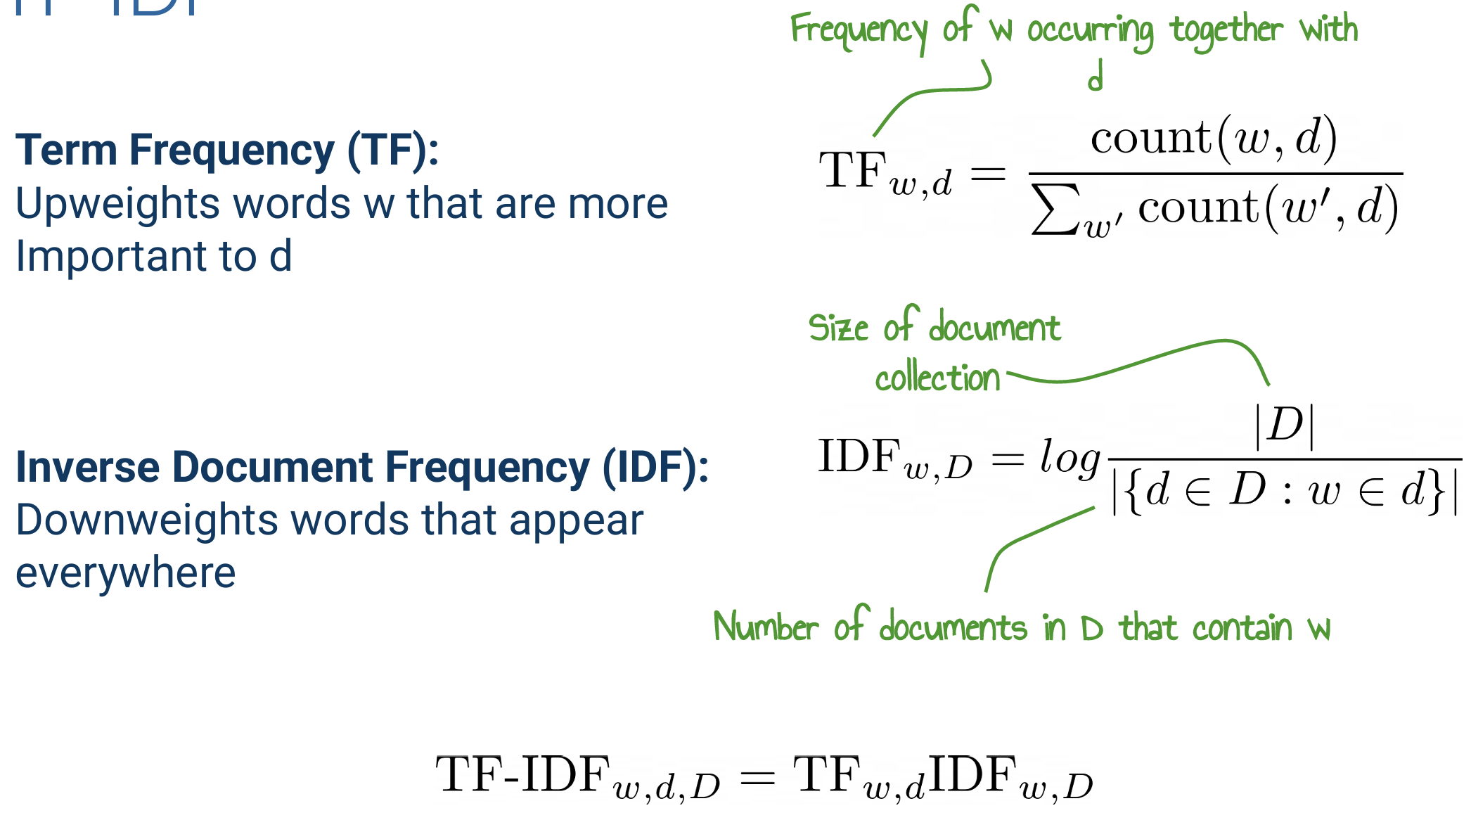

**Classification**:

**Naïve Bayes**:

$$x\text{ is a set of features }x_{1},x_{2},…,x_{I}$$

$$\hat{y}=argmax_{y}P\left(x_{1},x_{2},…,x_{I} | y\right)P\left(y\right)$$

Independence assumption:

$$P\left(x_{1},x_{2},…,x_{I} | y\right)=P\left(x_{1} | y\right)⋅P\left(x_{2} | y\right)⋅…⋅P\left(x_{I} | y\right)$$

**Final form**:

$$\hat{y}=argmax_{y}P\left(y\right)\prod_{i=1}^{I}{P\left(x_{i} | y\right)}$$

**Add-one smoothing**:

$$P\left(x_{i} | y\right)=\frac{\text{count}\left(x_{i},y\right)+1}{\sum_{x∈V}{\left(\text{count}\left(x,y\right)+1\right)}}=\frac{\text{count}\left(x_{i},y\right)+1}{\left(\sum_{x∈V\text{count}}{\left(x,y\right)}\right)+\left|V\right|}$$

**Example**:

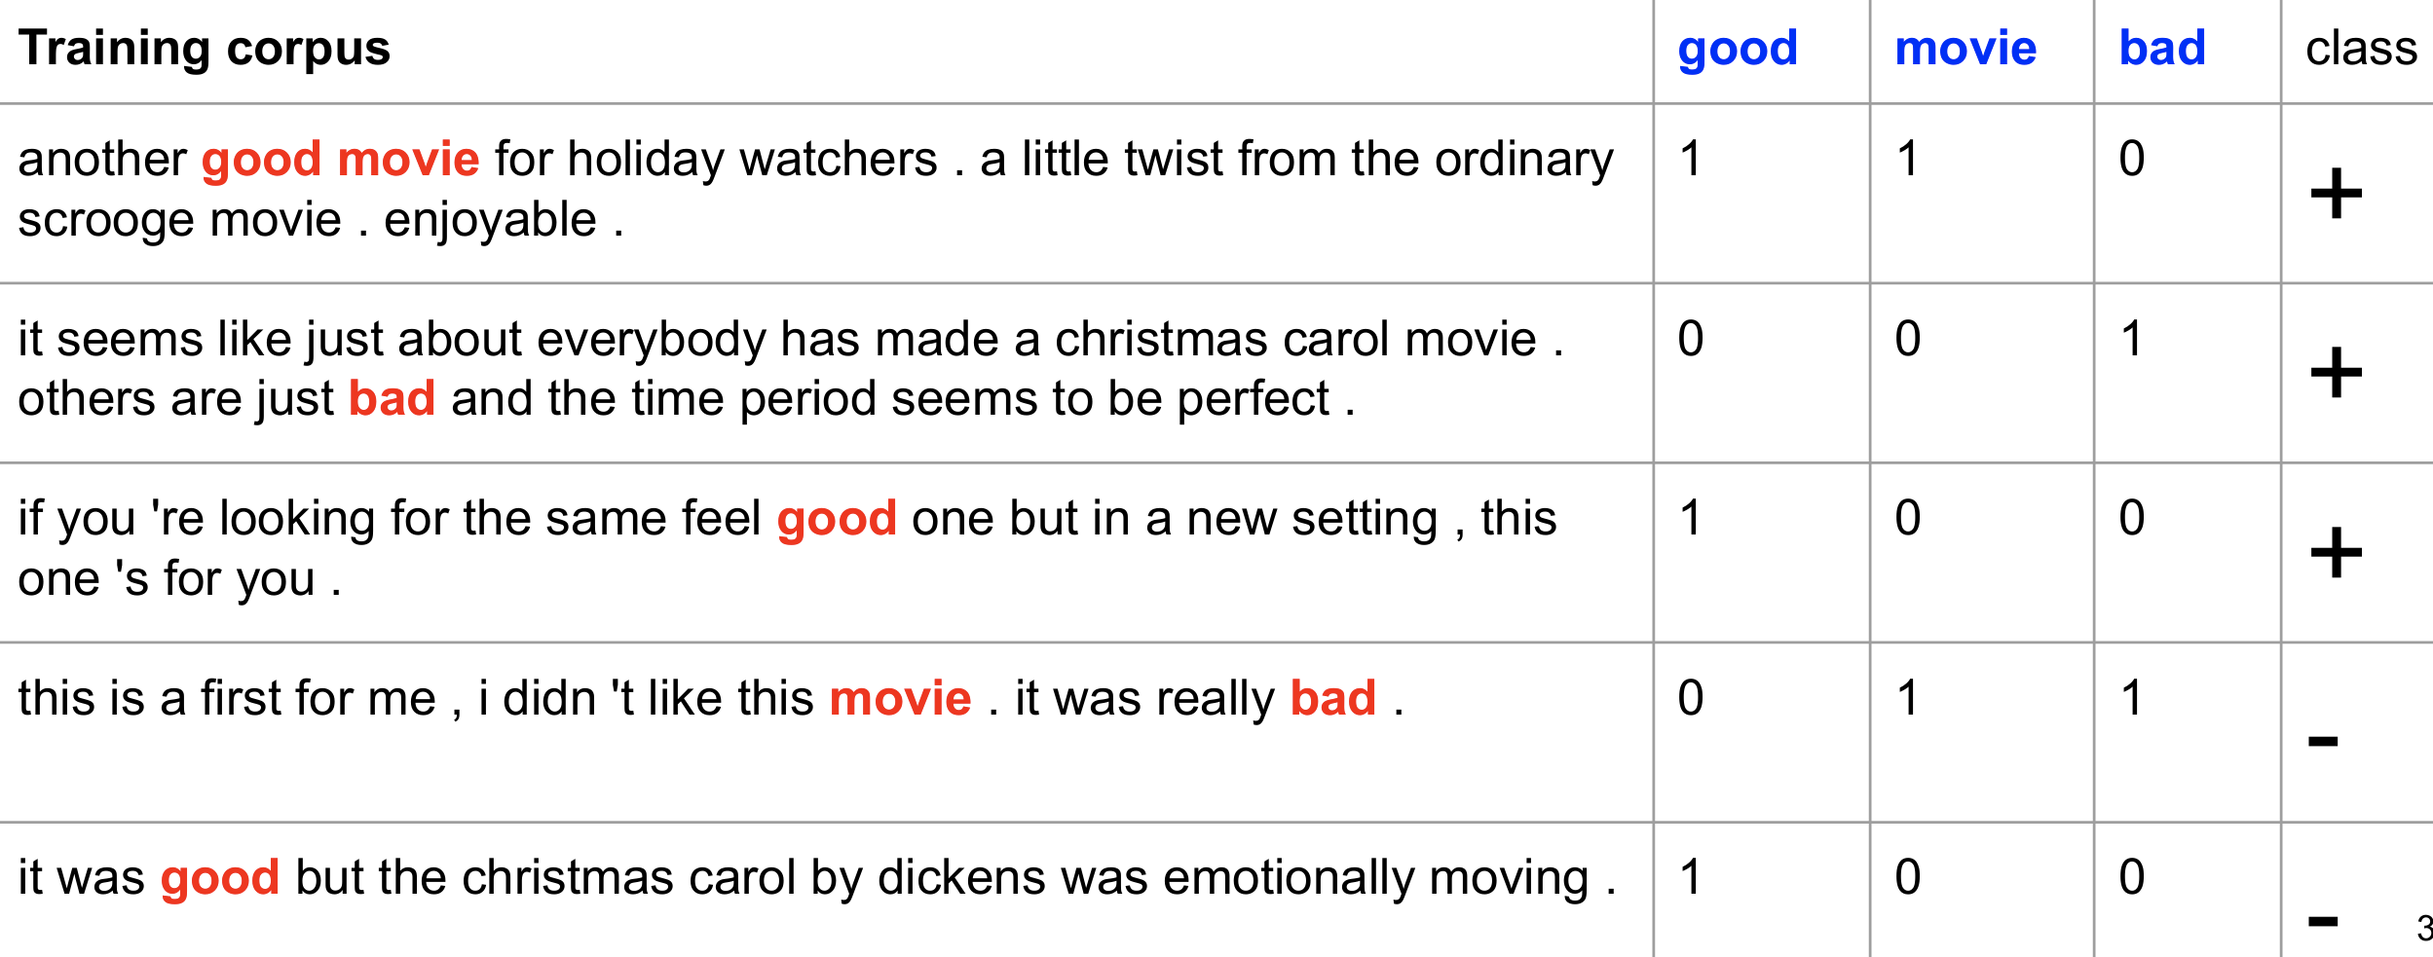

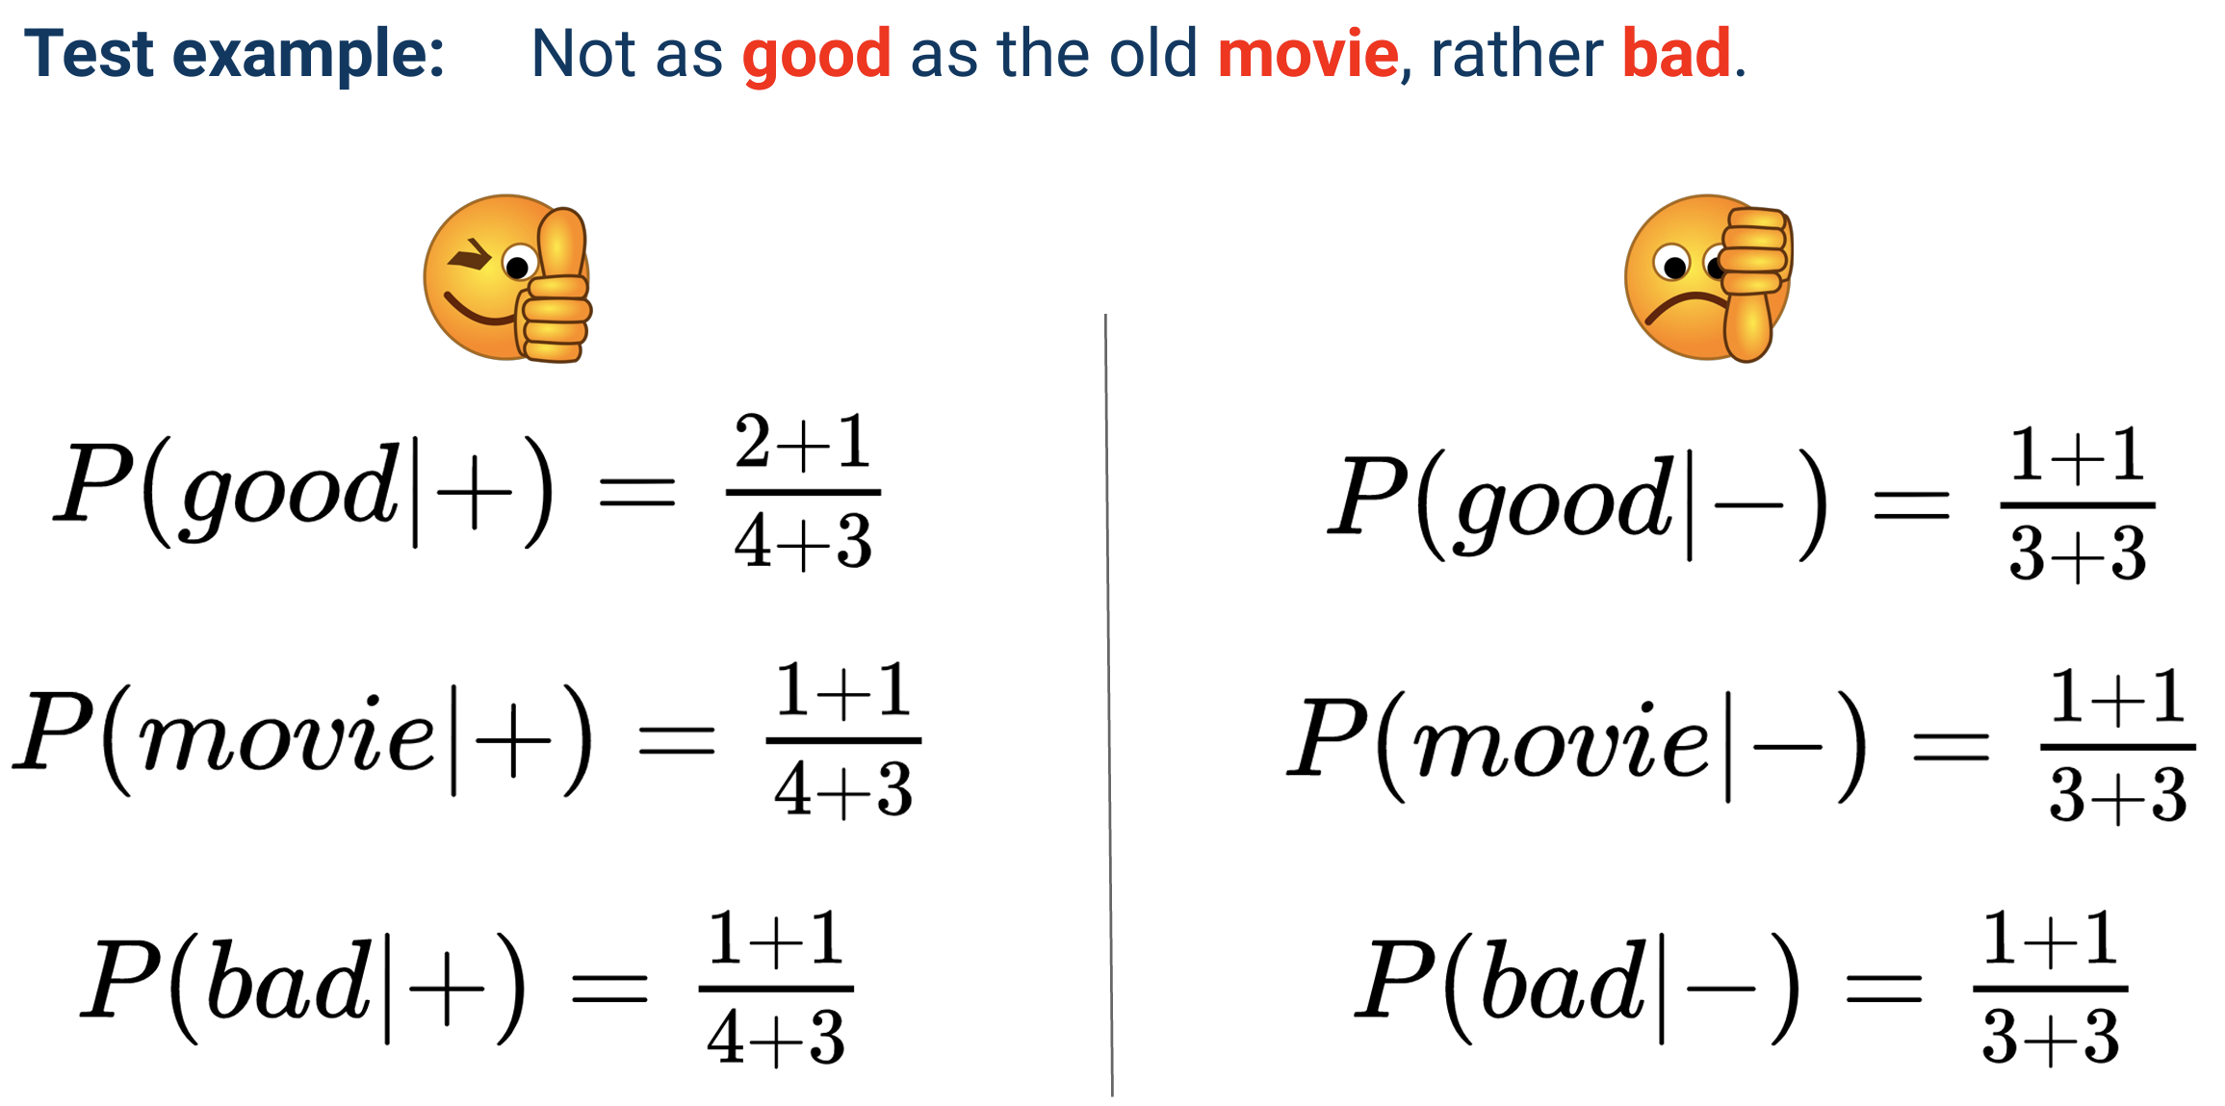

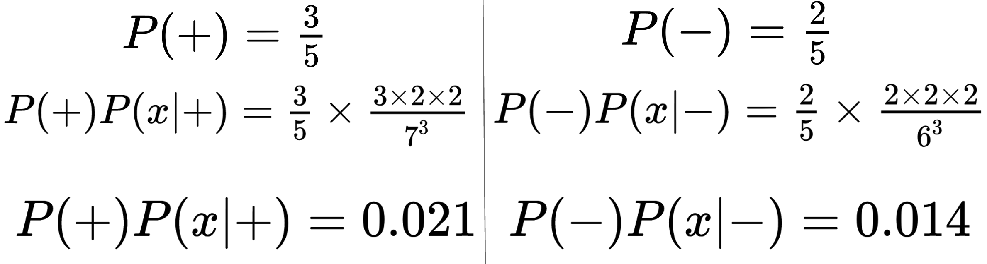

**Improvements**:

1. Binary naïve bayes: remove all duplicates within each instance

2. Controlling for negation

I didn’t like the movie, … ->

I didn’t NOT_like NOT_the NOT_movie, …

**Append** ‘NOT_’ after any logical negation (n’t, not, no, never) until the next punctuation mark

**Problems**:

1. Conditional independence assumption 2. Context of words not taken into account 3. New words (not seen at training) cannot be used

**Logistic regression**:

$$y\left(x\right)=g\left(z\right)=\frac{1}{1+e^{-z}},z=w⋅x+b$$

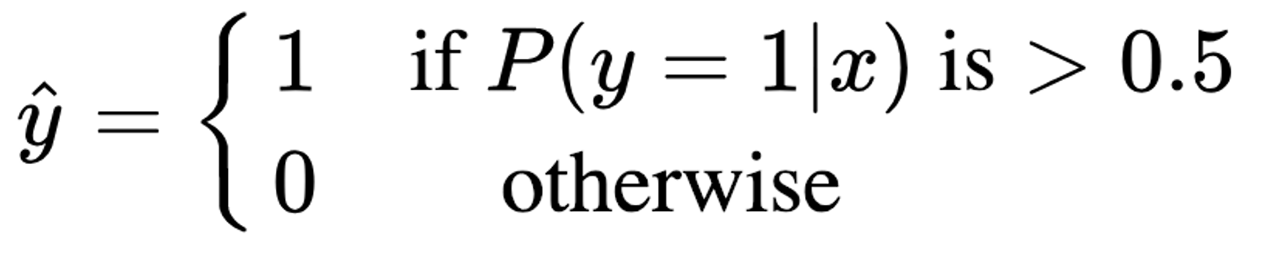

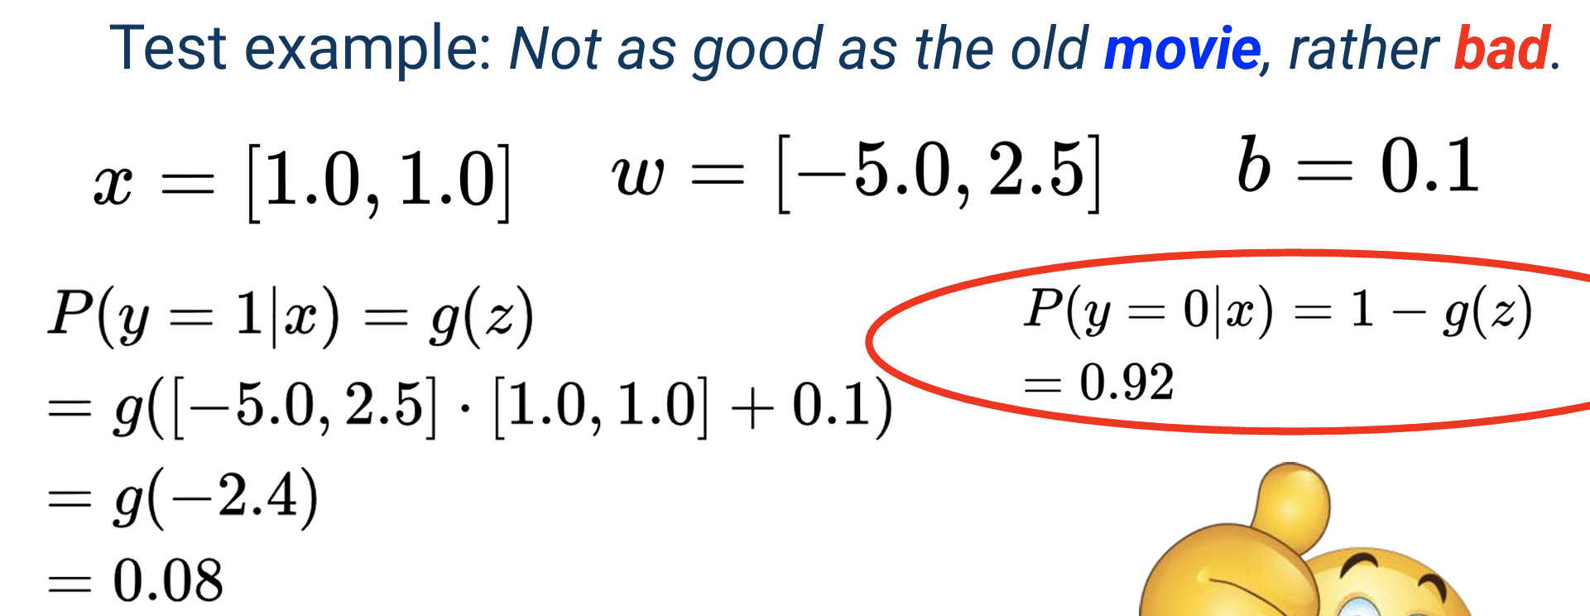

**Loss function**:

$$H\left(P,Q\right)=-\sum_{i}{P\left(y_{i}\right)\log{Q}\left(y_{i}\right)}$$

Multiple class: many z and x + softmax

**Discussion**:

LR: 1. Considers the importance of features, so better at dealing with correlated features 2. Better with larger datasets

NB: Very quick to train

**Neural Networks**:

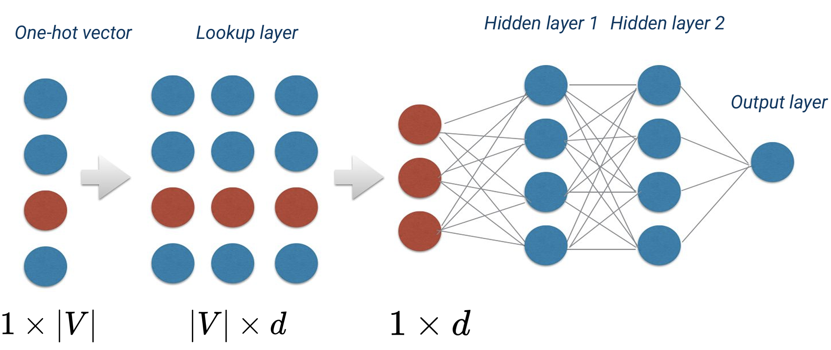

Care ‘**Lookup layer**’

If you want to perform **document representation**, cannot simply average all word representations: 1. Model architecture fixed to sentence length size 2. Model weights learnt for specific word positions

**Recurrent Neural Networks**:

**Vanilla RNNs**:

RNN(f) computes its next state $h_{t+1}$ based on: Hidden state vector $h_{t}$ and input vector $x_{t}$ at time t:

$$h_{t+1}=f\left(h_{t},x_{t}\right)=\tanh\left(Wh_{t}+Ux_{t}\right)$$

$W∈R^{H×H},U∈R^{H×E}$, E: embedding size

W: hidden-to-hidden, U: input-to-hidden

**Limitations** - Vanishing gradient problem: 1. Model is less able to learn from earlier inputs 2. Gradient for earlier layers involves repeated multiplication of the same matrix W

**Convolutional Neural Networks**:

**Filter**: Width=embedding dimension, Height = normally 2 to 5 (bigrams to 5-grams)

**RNNs vs. CNNs**:

CNNs can perform well if the task involves key phrase recognition whereas RNNs perform better when you need to understand longer range dependencies

**Evaluations**:

$$\text{Accuracy}=\frac{TP+TN}{TP+FP+TN+FN}$$

$$\text{Accuracy}=\frac{\sum_{i}^{C}{TP_{i}}}{\left|\text{Dataset}\right|}$$

$$F1=\frac{TP}{TP+\frac{1}{2}\left(FP+FN\right)}$$

$$\text{Micro averaged}$$

$$F1=\frac{\sum_{i}^{C}{TP_{i}}}{\sum_{i}^{C}{TP_{i}}+\frac{1}{2}\left(\sum_{i}^{C}{FP_{i}}+\sum_{i}^{C}{FN_{i}}\right)}$$

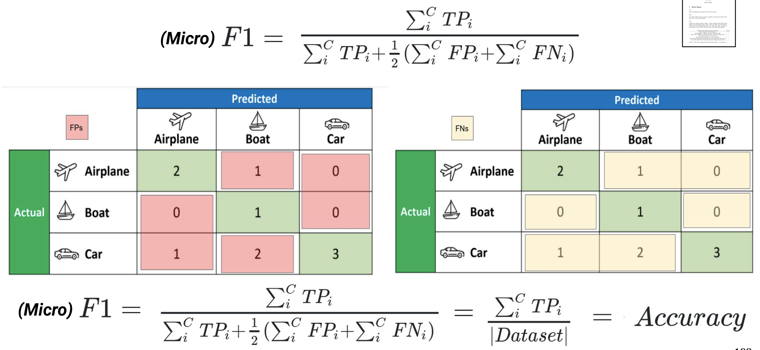

**Language Modelling**

**N-gram Modelling**:

**Assumption**: N-gram models approximate history by just the few last words

$$P\left(w_{n} | w_{1}^{n-1}\right)≈P\left(w_{n} | w_{n-N+1}^{n-1}\right)$$

**Bigrams to N-grams**:

$$P\left(w_{n} | w_{n-1}\right)=\frac{C\left(w_{n-1}w_{n}\right)}{C\left(w_{n-1}\right)}$$

$$P\left(w_{n} | w_{n-N+1}^{n-1}\right)=\frac{C\left(w_{n-N+1}^{n-1}w_{n}\right)}{C\left(w_{n-N+1}^{n-1}\right)}$$

Corpus size: 1. The larger the corpus, the larger n possible 2. Trigrams are often enough

**Perplexity**:

**Language Model Prob**:

$$P\left(w_{1},…,w_{n}\right)=P\left(w_{1}\right)P\left(w_{2} | w_{1}\right)P\left(w_{3} | w_{1},w_{2}\right)…P\left(w_{n} | w_{1}^{n-1}\right)$$

$$P\left(w_{1},…,w_{n}\right)=\prod_{k=1}^{n}{P\left(w_{k} | w_{1}^{k-1}\right)}$$

**Perplexity**: $PPL\left(W\right)=P{\left(w_{1},w_{2},…,w_{n}\right)}^{-\frac{1}{n}}$

$$=\sqrt[n]{\frac{1}{\prod_{k=1}^{n}{P\left(w_{k} | w_{1}^{k-1}\right)}}}$$

If Bigram:

$$PPL\left(W\right)=\sqrt[n]{\frac{1}{\prod_{k=1}^{n}{P\left(w_{k} | w_{k-1}\right)}}}$$

$$n=\# transitions$$

Low ppl = good

Cons: 1. Perplexity is specific to the test-set 2. How you tokenize the data matters

**Converting between CE and PPL**:

$$PPL=e^{H}\left(base e\right) or 2^{H}\left(base 2\right)$$

Extrinsic evaluation: Improve downstream task performance

Intrinsic evaluation: Perplexity

**Sparsity**:

**Add-one smoothing**:

$$P_{\text{add}\text{-}\text{1}}\left(w_{n} | w_{n-1}\right)=\frac{C\left(w_{n-1},w_{n}\right)+1}{C\left(w_{n-1}\right)+V}$$

**Discussion**: (+) Easy to implement (-) 1. Takes too much probability mass from more likely occurrences 2. Assigns too much probability to unseen events-> Try +k smoothing (small k)

**Back-off smoothing**:

Recursively: $S\left(w_{i} | w_{i-2}w_{i-1}\right)=$

$$\frac{C\left(w_{i-2}w_{i-1}w_{i}\right)}{C\left(w_{i-2}w_{i-1}\right)}\text{if }C\left(w_{i-2}w_{i-1}w_{i}\right)>0$$

$$0.4⋅S\left(w_{i} | w_{i-1}\right)\text{ot}\text{h}\text{erwise}$$

$S\left(w_{i}\right)=\frac{C\left(w_{i}\right)}{N}$, N = #words in the text

**Interpolation**: Combine evidence from different N-grams

$$P_{interp}\left(w_{i} | w_{i-2}w_{i-1}\right)=λ_{1}P\left(w_{i} | w_{i-2}w_{i-1}\right)+λ_{2}P\left(w_{i} | w_{i-1}\right)+λ_{3}P\left(w_{i}\right)$$

$$λ_{1}+λ_{2}+λ_{3}=1$$

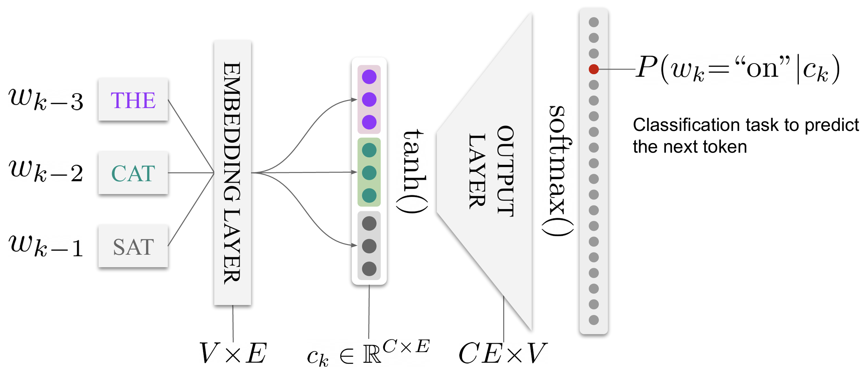

**RNNs**:

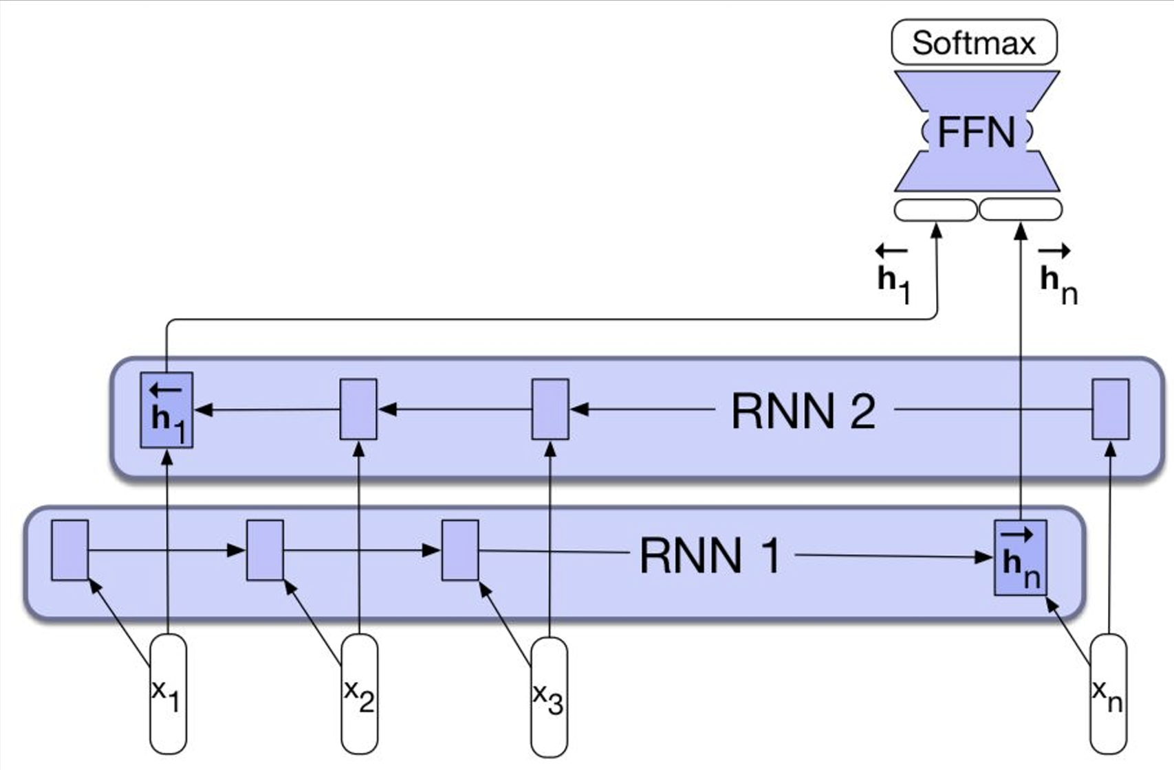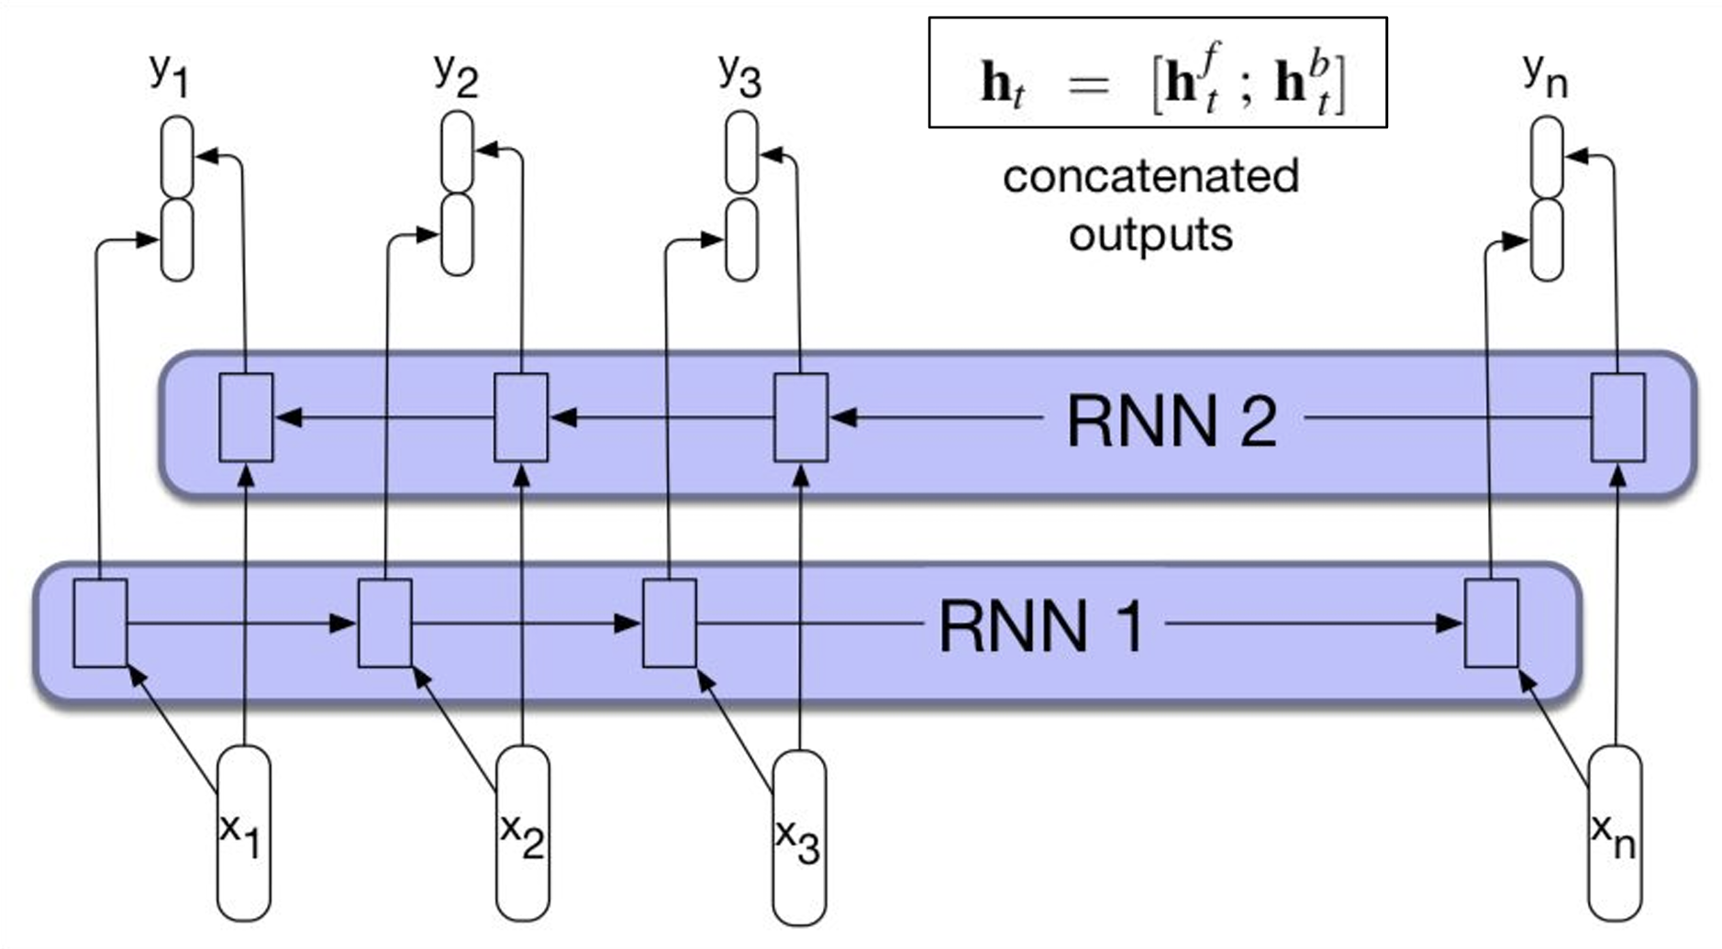

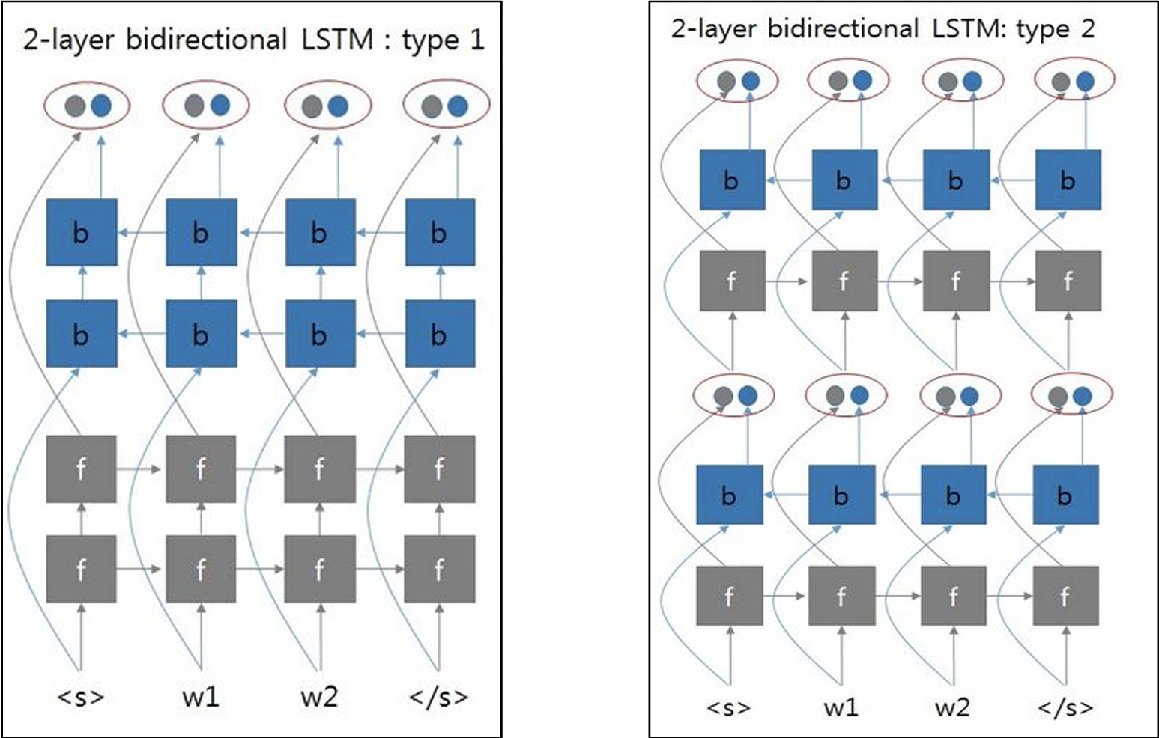

**LSTMs**: Cell states represent ‘long term memory’

**Input**: $i_{t}=σ\left(W_{ii}x_{t}+W_{hi}h_{t-1}+b_{i}\right)$

**Forget**: $f_{t}=σ\left(W_{if}x_{t}+W_{hf}h_{t-1}+b_{f}\right)$

**Output**: $o_{t}=σ\left(W_{io}x_{t}+W_{ho}h_{t-1}+b_{o}\right)$

$$g_{t}=\tanh\left(W_{ig}x_{t}+W_{hg}h_{t-1}+b_{g}\right)$$

$$c_{t}=f_{t}*c_{\left(t-1\right)}+i_{t}*g_{t},h_{t}=o_{t}*tanh\left(c_{t}\right)$$

**Forget Gate**: how much do we use the long-term memory (vector in (0,1))

**Input Gate**: how much do we use the output from step 1 (vector in (0,1))

**Output Gate**: An opportunity to scale $c_{t}$, multiplying by a vector of values between 0,1. The output gate and tanh is what differentiates $h_{t}$ and $c_{t}$

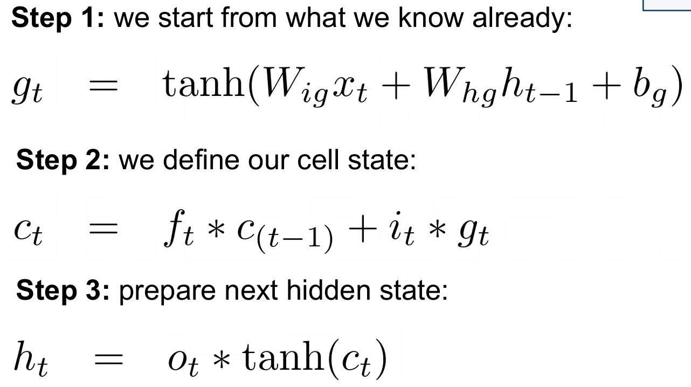

**Example**: Emb_dim=500, Hid_dim=100, Classification task=5 classes (with no bias term)

Excl. any embedding layer, parameters:

$$\left(100*500+100*100+100\right)*4+100*5$$

Bi-directional LSTM:

$$\left(100*500+100*100+100\right)*4*2+200*5$$

**Why cell state helps?**

The gradients through the cell states are hard to vanish: 1. Additive formula=no repeated multiplication of the same matrix 2. Forget gate=our model can learn when to let the gradients vanish and when to preserve them

**GRUs**:

**Reset**: $r_{t}=σ\left(W_{ir}x_{t}+W_{hr}h_{t-1}+b_{r}\right)$

**Update**: $z_{t}=σ\left(W_{iz}x_{t}+W_{hz}h_{t-1}+b_{z}\right)$

$$g_{t}=\tanh\left(W_{ig}x_{t}+r_{t}*\left(W_{hg}h_{t-1}+b_{g}\right)\right)$$

$$h_{t}=\left(1-z_{t}\right)*g_{t}+z_{t}*h_{t-1}$$

**Difference**: 1. No output gate 2. $\left(1-z_{t}\right) and z_{t}$ 3. Reset gate

**Machine Translation**

**Statistical Machine Translation**

**Sub-models**: 1. Alignment model 2. Translation model 3. Language model

We want to model $p\left(t | s\right)=\frac{p\left(t\right)p\left(s | t\right)}{p\left(s\right)}$

$p\left(t\right)$ is language model and $p\left(s | t\right)$ is translation model: how likely is

the source sentence given a candidate target sentence

Cons: 1. Sentence Alignment-Long sentences in source can be broken up into multiple sentences in target 2. Word Alignment-Some words do not have an equivalent in a target language 3. Statistical anomalies 4. Idioms 5. OOV

**Neural Machine Translation**

Encoder-Decoder

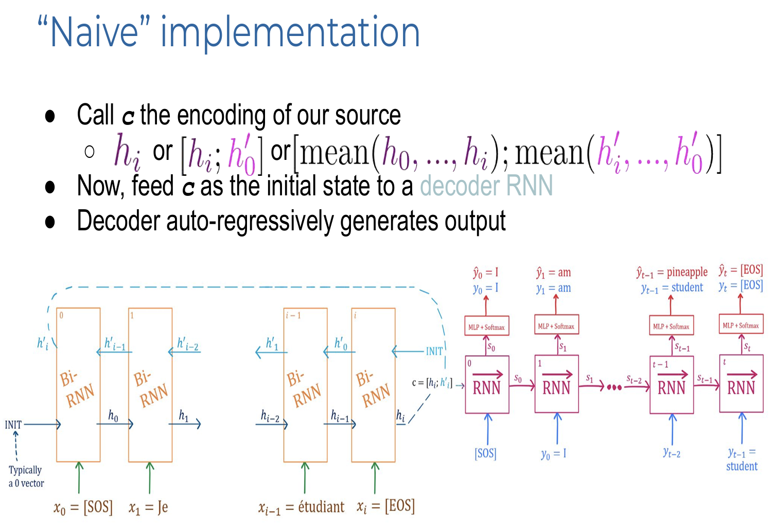

**Teacher Forcing**: Feeding the ground truth token to the next decoder cell

No TF leads to an accumulation of errors and optimization is difficult

**Exposure Bias**: data distribution the model is conditioned on vary between training and inference

**Why length+ performance-**?

All sequences are being represented by a d-dimensional vector. For longer sequence lengths, the ability to retain all the source information in this vector diminishes. From the decoder side of things, as more words get decoded ad the hidden state gets updated to incorporate the previously generated words, information from the context vector may start to diminish (vanishing gradients and lack “remember” ability)

**Attention**:

**Alignment function**:

$$e_{i}=a\left(s_{t-1},h_{i}\right)=v^{T}\tanh\left(Ws_{t-1}+Uh_{i}\right)$$

$e_{i}$ is unnormalized energy score for each source word i; $s_{t-1}∈R^{D×1}$ is previous decoder hidden state; $h_{i}∈R^{2D×1}$ is encoder hidden state for the ith word. $v^{T}∈R^{D×1}$, $W∈R^{D×D}$, $U∈R^{D×2D}$

**5 steps**: 1. Project s and h to D-dimensional vector 2. Add projected vector, tanh activation 3. V is for creating the energy score, projects the D-dimensional vector down to a scalar

**Context vec**: $c_{t}=\sum_{i=0}^{I}{α_{i}h_{i}}$

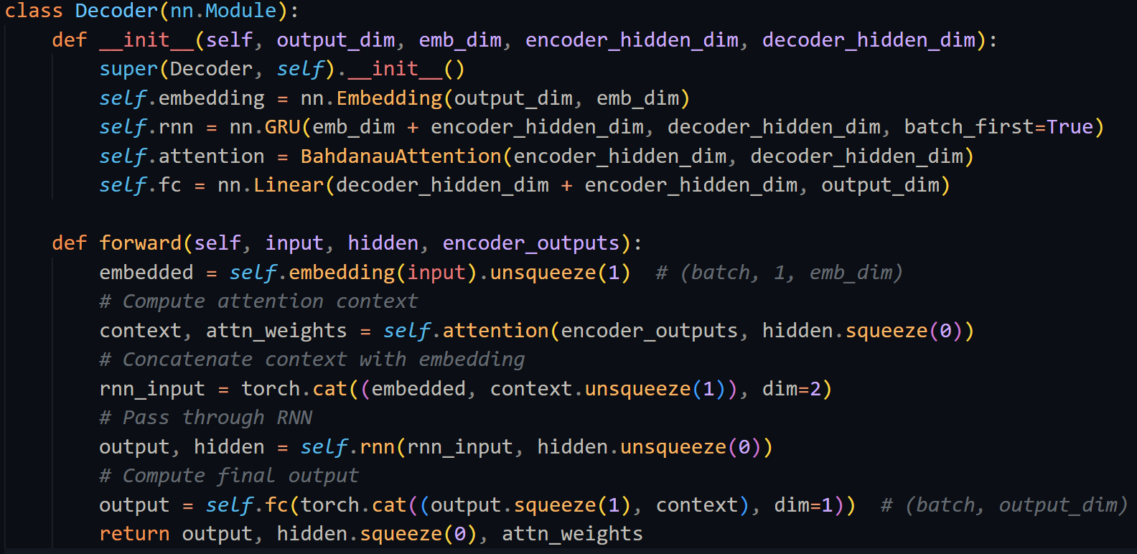

**Evaluation metrics of MT/NLG systems**

**BLEU**:

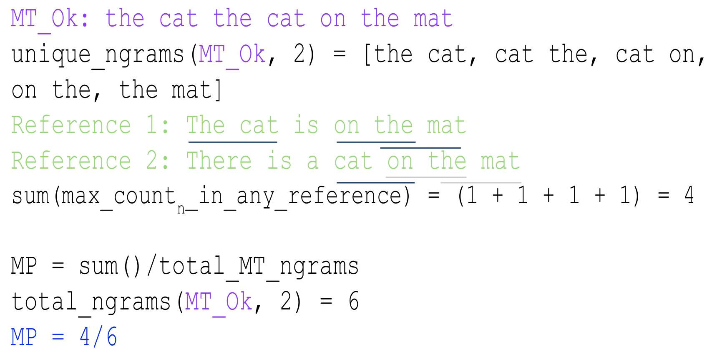

$$p_{n}=\frac{\text{Total Unique }{\text{Overlap}}_{n}}{\text{Total }n\text{-}\text{grams}}$$

$$\text{BP}=\min\left(1,\frac{\text{MT Output Lengt}\text{h}}{\text{Reference Lengt}\text{h}}\right)$$

$$\text{BLEU}\text{-}\text{4}=\text{BP}{\left(\prod_{n=1}^{4}{p_{n}}\right)}^{1/4}$$

**Chr-F**: Character n-gram $F_{β}$ score

Balances character precision and character recall

**TER**: Translation Error Rate

Minimum # of edits required to change a hypothesis into one of the references

**ROUGE**:

ROUGE-n: Measures the F-Score of n-gram split references and system outputs.

ROUGE-L: F-Score of the longest common subsequence shared between references and system outputs.

Ref: The car is on the mat; Hyp: The cat and the dog. LCS = “the cat the”

Precision=3/5, Recall=3/6, then calc F1

**METEOR**:

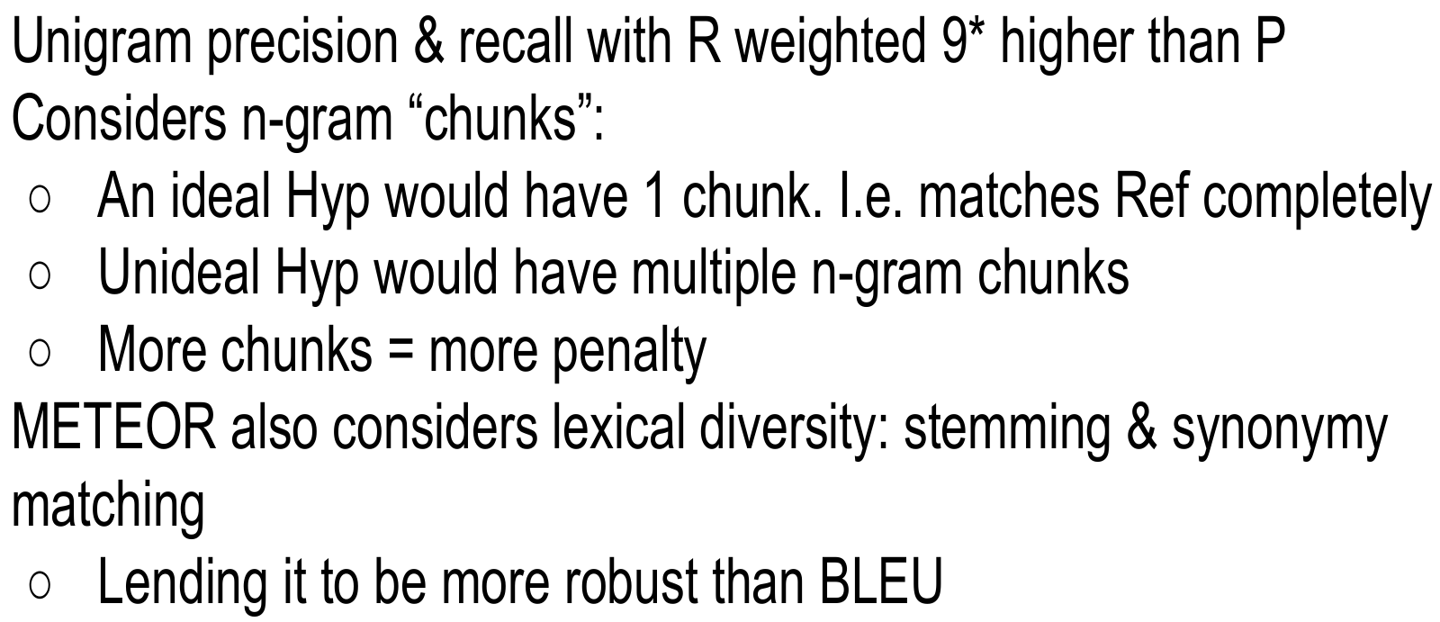

**BERTScore**:

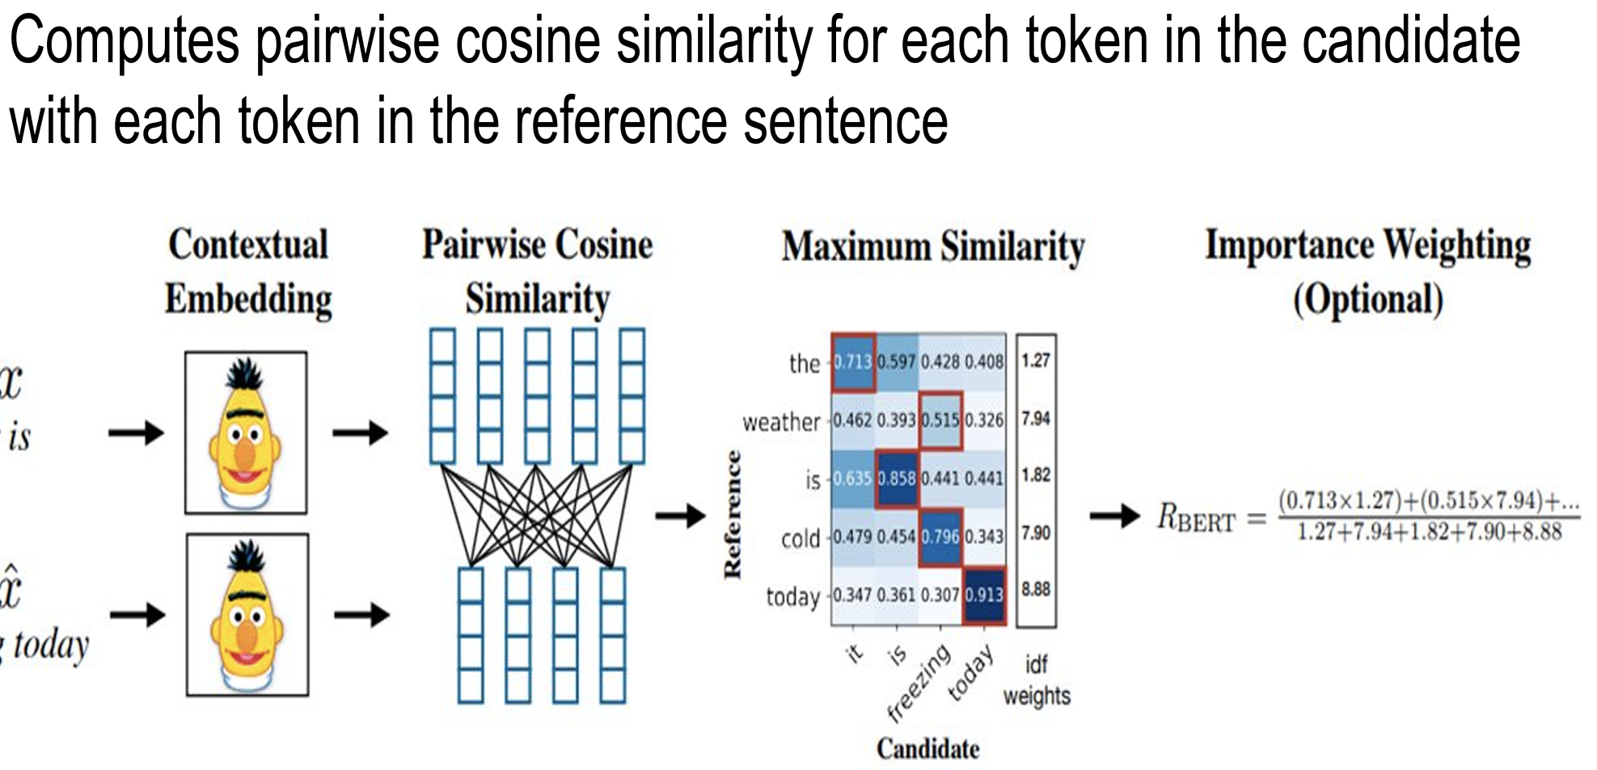

**Inference**:

**Beam Search**: (normally k: 5-10)

**Temperature Sampling**: solve “deterministic” problem; sample instead of argmax; softmax is peaky.

1. Divide logits by T. Run softmax 2. Multinomial sample over softmax probs. $\frac{e^{\frac{y_{i}}{T}}}{\sum_{j=1}^{N}{e^{\frac{y_{j}}{T}}}}$

**Data augmentation**

**Backtranslation**: 1. Train/use a **separate** **target-source** model 2. Translate target monolingual corpora to source using the model 3. Train the **actual** **source-to-target** model with additional data 4. Ideally changes the syntax of source while keeping the same semantics (-) add noise

**Synonym replacement**: 1. Dictionary / syntax trees 2. Word embeddings / nearest-neighbours

**Batching, Padding and Sequence** Length: 1. Group similar length sentences together in the batch 2. Train your model on simpler/smaller sequences lengths first